Figure 1

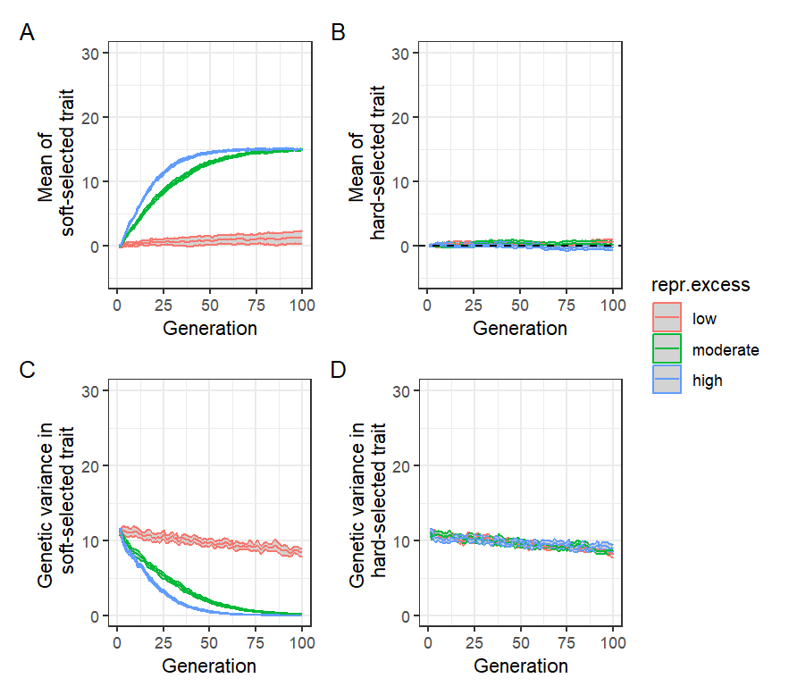

Fig.1 Results of baseline simulations set 1. No intrusion of foreign/domesticated fish occurred, and the population was assumed to be initially well-adapted with respect to the hard-selected trait. Red = low reproductive excess (); green = moderate reproductive excess (); blue = high reproductive excess (). Mean and 95% confidence intervals (grey ribbons) across 1000 replicate simulations shown. (A) Changes in mean of soft-selected trait () over time. (B) Changes in mean of hard-selected trait () over time (dashed line indicates optimum). (C) Changes in genetic variance of over time. (D) Changes in genetic variance of over time.

Figure 2

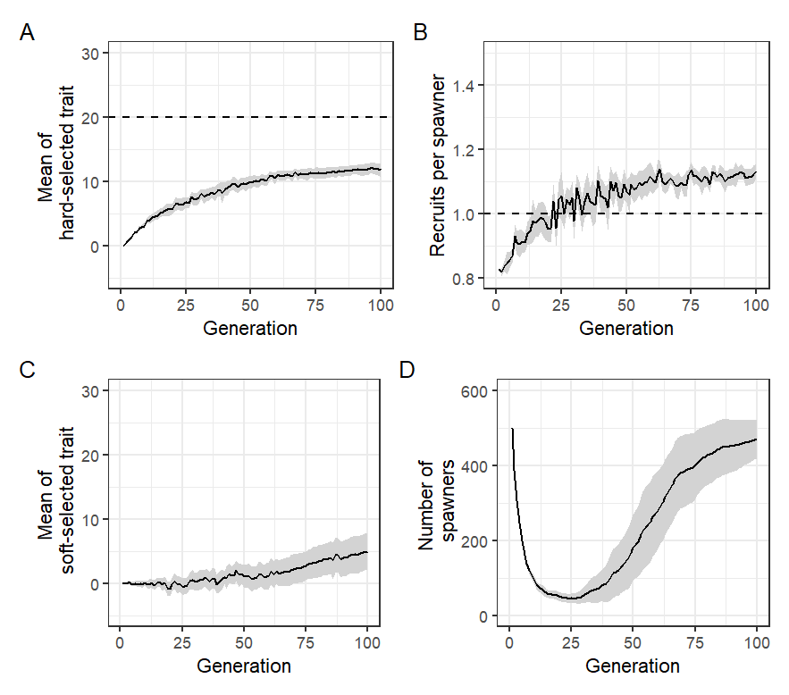

Fig.2: Results of baseline simulations set 2. No intrusion of foreign/domesticated fish occurred, and the population was assumed to be trait (initial . Moderate reproductive excess () was assumed and initial 0.25. Mean and 95% confidence intervals (grey ribbons) across 1000 replicate simulations shown. (A) Evolutionary trajectory of (dashed line = optimum). (B) Changes in recruits per spawner () over time where the dashed line represents exact population replacement (i.e. no increase/decrease between generations). (C) Evolutionary trajectory of . (D) Trajectory of number of spawners over time. In all panels, averages taken each generation over only those replicate populations that persisted ().

Figure 3

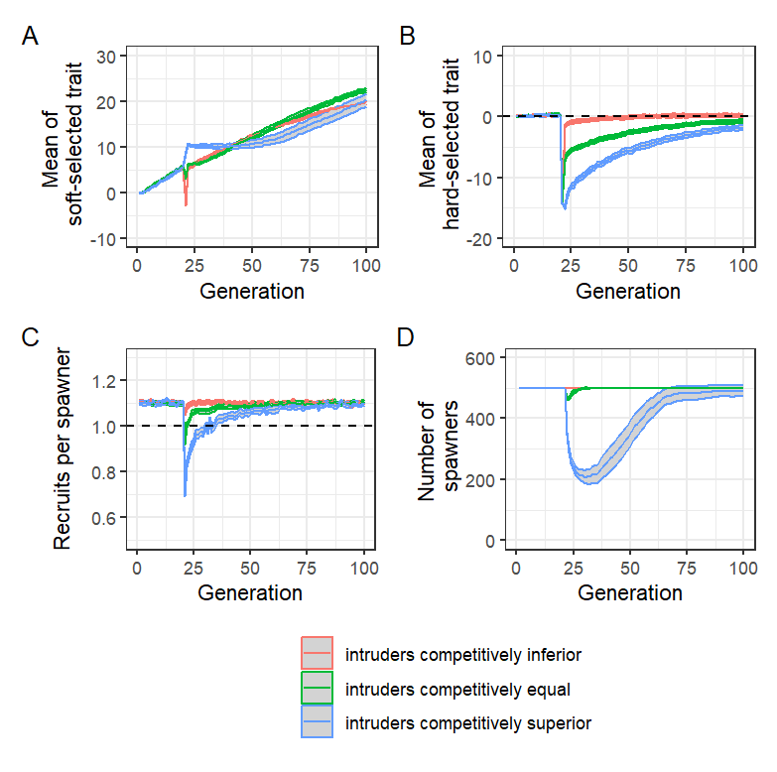

Fig.3: Results of acute intrusion simulations set 1. Prior to intrusion in generation 20, the wild population has a of ~1.1 (), such that ~550 recruits compete for = 500 spawning slots. At generation 20, 500 foreign/domesticated fish intrude just prior to spawning, giving ~1050 fish in total, greatly intensifying competition for the 500 spawning slots. Results of three scenarios (mean and 95% confidence intervals across 1000 replicates) are shown: red = intruders competitively inferior to locals; green = intruders competitively equal to locals, and blue = intruders competitively superior to locals. The intruders are maladapted with respect to in all three cases, so goes down in generation 20 but then slowly recovers as of the mixed population evolves back up towards the fixed optimum (; dashed line in B). (A) Evolutionary trajectory of . (B) Evolutionary trajectory of . (C) Trajectory of over time (dashed line = replacement). (D) Trajectory of number of spawners over time. Initial = 0.25.

Figure 4

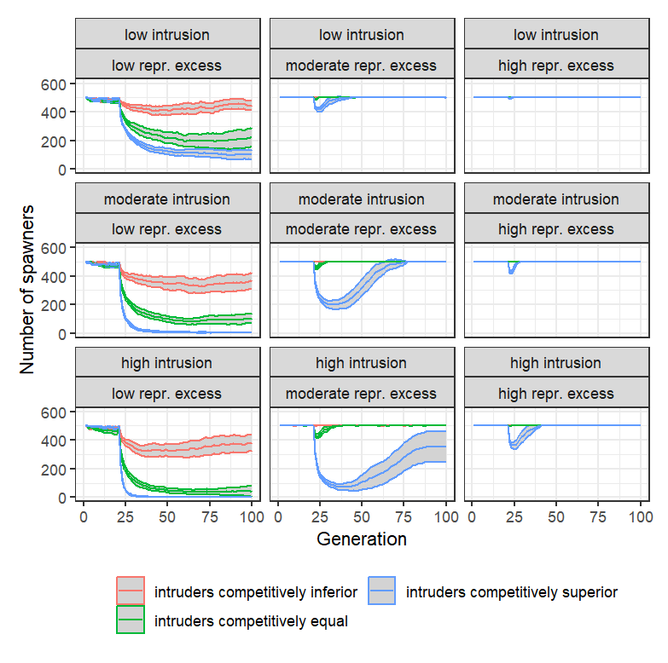

Fig.4: Results of acute intrusion simulations set 2. Mean and 95% confidence intervals across 1000 replicates shown. Red = intruders competitively inferior to locals; green = intruders competitively equal to locals, and blue = intruders competitively superior to locals. =500 in all scenarios. Low intrusion = 250 intruders introduced in generation 21; moderate intrusion = 500 intruders introduced; high intrusion = 750 intruders introduced. Low reproductive excess: ; moderate reproductive excess: ; high reproductive excess: . Each panel shows the trajectory of number of spawners over time, with the average taken each generation over only those replicate populations that persisted (). Initial = 0.25.

Figure 5

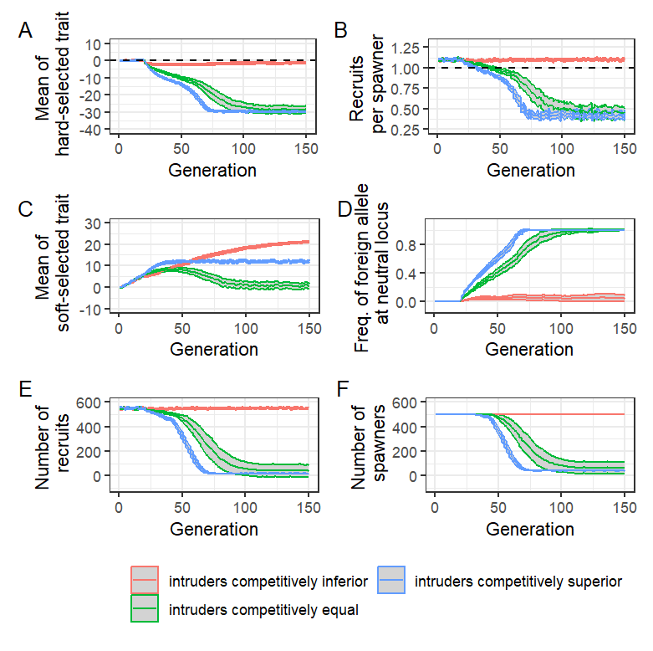

Fig.5: Results of chronic intrusion simulations set 1. Prior to intrusion in generation 21, the wild population has a of ~1.1 (), such that ~550 recruits compete for = 500 spawning slots. From generation 21 onwards, 25 foreign/domesticated fish intrude each generation just prior to spawning. Results of three scenarios (mean and 95% confidence intervals across 1000 replicates) are shown: red = intruders competitively inferior to locals; green = intruders competitively equal to locals, and blue = intruders competitively superior to locals. The intruders are maladapted with respect to in all three cases. (A) Evolutionary trajectory of (dashed line = optimum). (B) Trajectory of over time (dashed line = replacement). (C) Evolutionary trajectory of . (D) Changes in frequency of foreign/domesticated allele at neutral locus over time. (E) Trajectory of number of spawners over time. (F) Trajectory of number of recruits over time. = 0.25.

Figure 6

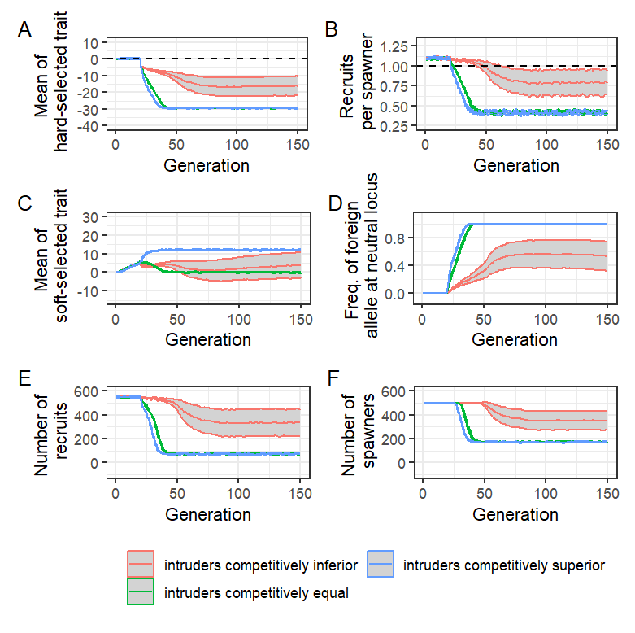

Fig.6: Results of chronic intrusion simulations set 2. Prior to intrusion in generation 20, the wild population has a of ~1.1 (), such that ~550 recruits compete for = 500 spawning slots. From generation 20 onwards, 100 foreign/domesticated fish intrude each generation just prior to spawning. Results of three scenarios (mean and 95% confidence intervals across 1000 replicates) are shown: red = intruders competitively inferior to locals; green = intruders competitively equal to locals, and blue = intruders competitively superior to locals. The intruders are maladapted with respect to in all three cases. (A) Evolutionary trajectory of (dashed line = optimum). (B) Trajectory of over time (dashed line = replacement). (C) Evolutionary trajectory of . (D) Changes in frequency of foreign/domesticated allele at neutral locus over time. (E) Trajectory of number of spawners over time. (F) Trajectory of number of recruits over time. Initial = 0.25.